Pizza Shop User Interface Project

Group #5

Created by:
Cheng Vang
Derek Valenzuela
Euphrates Youngblood
Justin Spratt
Kyle Simmons
Kylie Uffens
Nailah Williams

06/01/2026

Table of Contents
Project Vision and Description and Scope 3
Team Roles 5
Collaboration Methodology 5
The Definition of “Done” 6
Product Design 10
High-Level Design Overview 10
Use Cases Covering Core Scope 11
Domain Model and Core Components 12
Sprint 1 Detailed Design 13
Sprint 1 - Primary UI Pages 13
Sprint 1 - Key API Endpoints (logical) 14
Sprint 1 - Data/Persistence Notes 14
Sprint 2 Detailed Design 14
Sprint 2 - Checkout and Payment Flow 15
Sprint 2 Payment Data-Flow Diagram and Trust Boundaries 17
Sprint 2 - Key API Endpoints (logical) 17
Security and Nonfunctional Design 18
Security Controls 18
Nonfunctional Requirements 18
Design Coverage Statement 19
Sprint 1 Retrospective Summary Report 19
Sprint 2 Retrospective Summary Report 20
References 22

Project Vision and Description and Scope

Product Description 3: Pizza Restaurant Online Ordering System
The owners of a pizzeria asked your team to create a responsive, simple, and user-friendly Web site. The Web site is expected to contain all information about the restaurant, including description, photos, menu items, prices, current discounts, and promotions. The main system features include the following:
- Project Goals & Objectives — Owner Input

Owner Goals
- I want a website that is simple, responsive, and easy for customers to use.
- I want customers to be able to browse the menu, see prices, view promotions, and place orders without confusion.
- I want the store manager to be able to update menu items, photos, and prices whenever needed.
Owner Objectives
- Give customers a smooth ordering experience from start to finish.
- Make sure the website automatically calculates the final bill based on their selections.
- Ensure online payments are handled safely and reliably.
- Give the manager a straightforward way to change menu items and promotions.

- Project Requirements — Owner Input
Owner Requirements
- I expect around 30–50 orders per day at first, but I want the system to be able to grow with the business.
- Payment processing must be secure and dependable since many customers prefer to pay online.
- Customer information should only include what’s needed for orders (name, phone, address, order details).
- Menu updates should be easy so the manager can change items without technical help.

- Project Exclusions — Owner Input

Owner Exclusions
- I do not need customer accounts, logins, or saved profiles for this version.
- I do not need advanced features like loyalty programs, reward points, or gift cards right now.
- I only want essential restaurant information displayed: menu, photos, hours, discounts, and promotions.
- No blog, newsletter, or marketing automation tools are needed at this stage.

- Project Constraints — Owner Input

Owner Constraints
- My budget is limited, so I want to prioritize:
- Reliable payment processing
- A smooth ordering flow
- I’m okay with a simple UI design as long as it’s clean and easy to navigate.
- Menu management must be simple because I don’t have technical staff.
- I expect order volume to increase over time, so the system should be able to scale without major redesign.

- Project Assumptions — Owner Input

Owner Assumptions
- I assume the development team will guide me on the best formats for menu photos, item descriptions, and pricing.
- I assume the payment processor will handle security and compliance requirements.
- I assume the website will work well on phones, tablets, and desktops.
- I assume I will receive instructions or training on how to update menu items and promotions.

- Project Deliverables — Owner Input

Owner Deliverables Needed
- A fully functional online ordering website allowing customers to browse the menu before placing an order.
- A simple admin panel for updating menu items, prices, photos, and promotions.
- A working payment integration that supports secure online payments.

Team Roles
Nailah Williams - Scrum Master
Euphrates Youngblood - Product Owner
Justin Spratt - Software Developer
Derek Valenzuela –Software Developer
Kyle Simmons - Software Developer
Kylie Uffens - Software Developer
Cheng Vang - Software Developer

Collaboration Methodology
Create a culture of trust. Team members collaborate best when they feel safe to share ideas and voice concerns. A work environment built on trust allows for open communication and productive discussions. Build Trust between teammates. Everyone should feel comfortable when getting in contact with one another. Communication with each other is key to getting a good product out to the customer. We have chosen to utilize Microsoft Teams for collaboration remotely as it allows us to conduct team meetings over voice/video while also allowing for screen and file sharing as needed. Cross-functional work improves when team members can access shared information instead of working in isolation. A collaborative team thrives when teams know how their work connects.
Streamline how information is shared. Miscommunication happens when files, messages, and updates are scattered across different platforms. Using team collaboration software keeps everything in one place, reducing confusion. When working on our tasks, make sure it is through one of the shared documents through OneDrive.
Use workplace collaboration tools. We will be working remotely through Microsoft Teams and sending messages updating each other on our progress with our tasks. Excel sheets and text documents will be uploaded to OneDrive as required. As the need arises, more tools will be utilized.
Support different working styles. Not all team members collaborate in the same way. Some may prefer structured team meetings, while others contribute more through messaging or brainstorming sessions. A flexible approach makes collaboration easier for everyone.

The Definition of “Done”
For this project, a feature, user story, or sprint task is considered done only when it meets the agreed project requirements, satisfies the acceptance criteria, and is reviewed by the team and Product Owner. “Done” means the work is functional, tested, documented, and ready to be included in the Pizza Restaurant Online Ordering System without requiring major rework.
A task or user story is considered complete when the following conditions are met:
- Requirement Alignment
The completed work directly supports the project scope, including restaurant information, menu browsing, pricing, promotions, cart management, checkout, order confirmation, secure payment processing, or manager administration. Any feature outside the approved scope, such as customer accounts, loyalty rewards, gift cards, blogs, or newsletters, is not included unless approved by the Product Owner.
- Acceptance Criteria Are Met
Each user story must meet its stated acceptance criteria. For example, customers must be able to view menu items and prices, add items to the cart, see accurate totals, enter only the required order information, submit payment securely, and receive an order confirmation. Manager-related stories must allow the manager to update menu items, prices, photos, and promotions without needing technical assistance.
- Functionality Has Been Tested
The feature must be tested to confirm that it works as expected. Testing should include normal use cases, error cases, and basic edge cases. For example, the cart should calculate totals correctly, invalid checkout information should display clear error messages, and payment failures should give the customer a safe retry path.
- Responsive User Interface
The user interface must work properly on desktop, tablet, and mobile screen sizes. Pages should be readable, navigation should be clear, buttons should be easy to use, and the ordering process should remain simple from start to finish.
- Security and Privacy Expectations Are Met
The system must follow the project’s security expectations. Customer data should be limited to only what is needed for the order, such as name, phone number, address, and order details. Payment card numbers must not be stored by the system. Admin functions must be protected so only authorized users can update menu items, prices, photos, and promotions.
- Code and Design Quality Are Reviewed
The team must review the completed work for accuracy, readability, and consistency with the project design. Code should be organized, understandable, and maintainable. The feature should fit the overall three-tier design of the Web UI, Backend API, Database, and external payment provider.
- No Major Defects Remain
A feature cannot be considered done if it contains major defects that prevent customers from ordering, managers from updating content, payments from processing, or order totals from calculating correctly. Minor issues may be documented for later work only if they do not block the main function of the system.
- Documentation Is Updated
Any related project documentation, diagrams, endpoint descriptions, screenshots, or sprint notes must be updated to reflect the completed work. If the feature changes the design, workflow, or system behavior, the project document should also be updated.
- Product Owner Review Is Completed
The Product Owner must review the completed work and confirm that it satisfies the intended business need. Once the Product Owner accepts the work, the team can mark the item as done.
Overall, “done” means the feature is complete, working, tested, secure, documented, and accepted. This helps the team avoid unclear expectations and ensures that each sprint produces usable progress toward the final pizza ordering website.

Product Design
This section provides a high-level architecture and detailed design artifacts for Sprints 1 and 2 of the Pizza Restaurant Online Ordering System. The design prioritizes a responsive, simple ordering flow, secure and dependable online payments, minimal customer data collection, and an admin experience that allows non-technical staff to update menu content.

High-Level Design Overview
Architecture style: a simple 3-tier web application (Web UI, Backend API, Database) integrated with an external payment provider. This approach supports the project constraints (limited budget, simple UI) while enabling growth beyond the initial 30–50 orders/day through horizontal scaling of the web/API tiers.
• Web UI (customer + manager): responsive pages for restaurant info, menu browsing, cart, checkout, and an admin panel.
• Backend API: REST endpoints for menu/promotions, cart pricing, order creation, and admin CRUD operations.
• Database: stores menu items, promotions, orders, and minimal customer order details (no saved profiles).
• Payment Provider: tokenized payment flow with Strong Customer Authentication / 3D Secure when required.
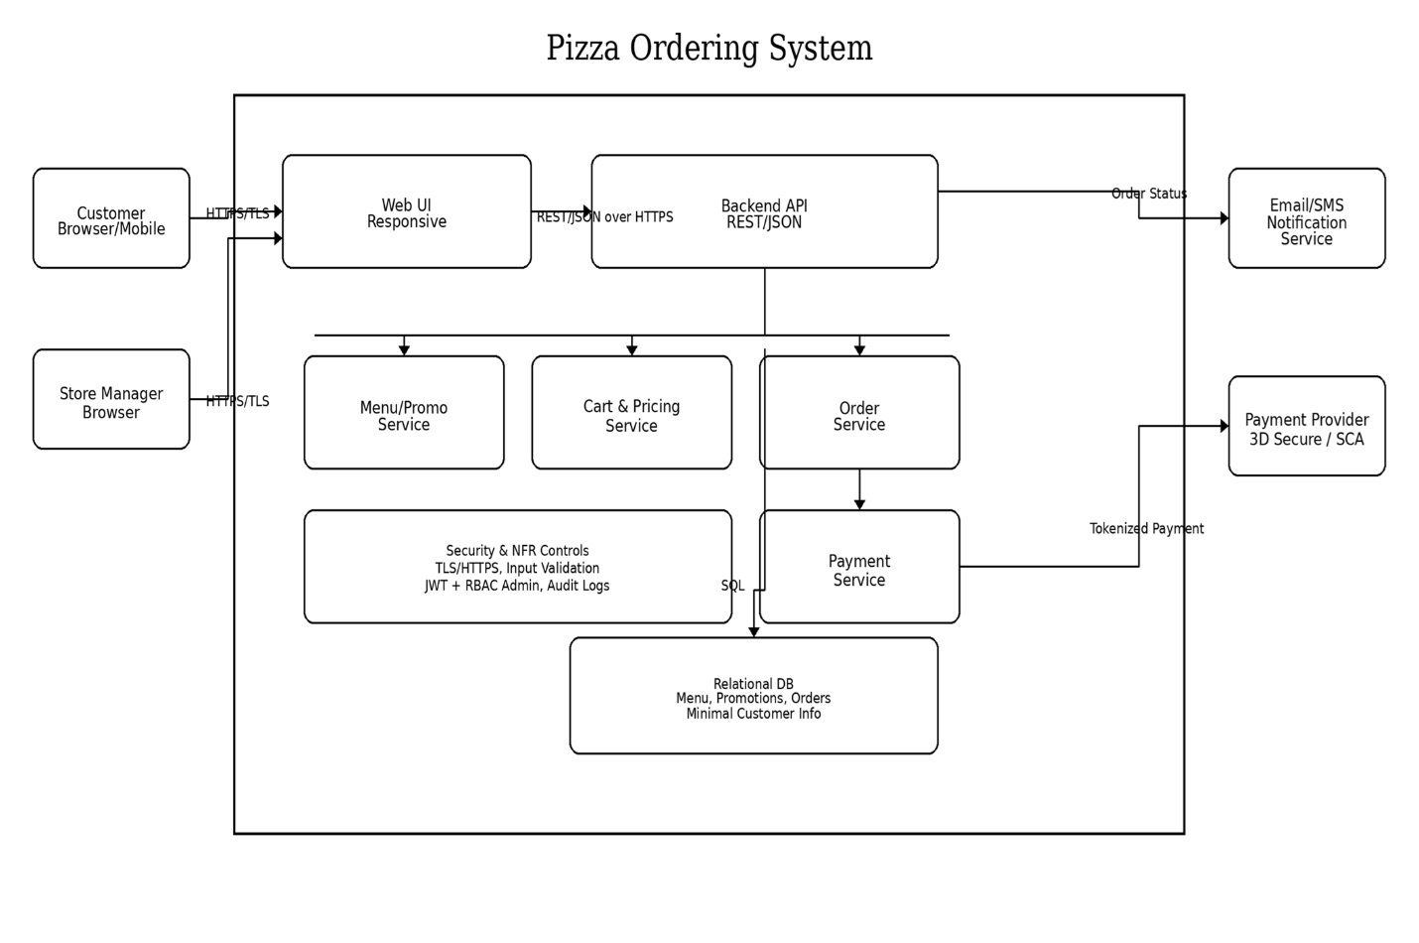
Figure 1. High-Level System Architecture for the Pizza Restaurant Online Ordering System

Use Cases Covering Core Scope
The use cases below cover the customer ordering journey (restaurant info → menu → cart → checkout → confirmation) and the manager’s administrative responsibilities (menu, prices, photos, promotions). Together, these represent the majority of the in-scope functionality while excluding accounts/logins/loyalty features.
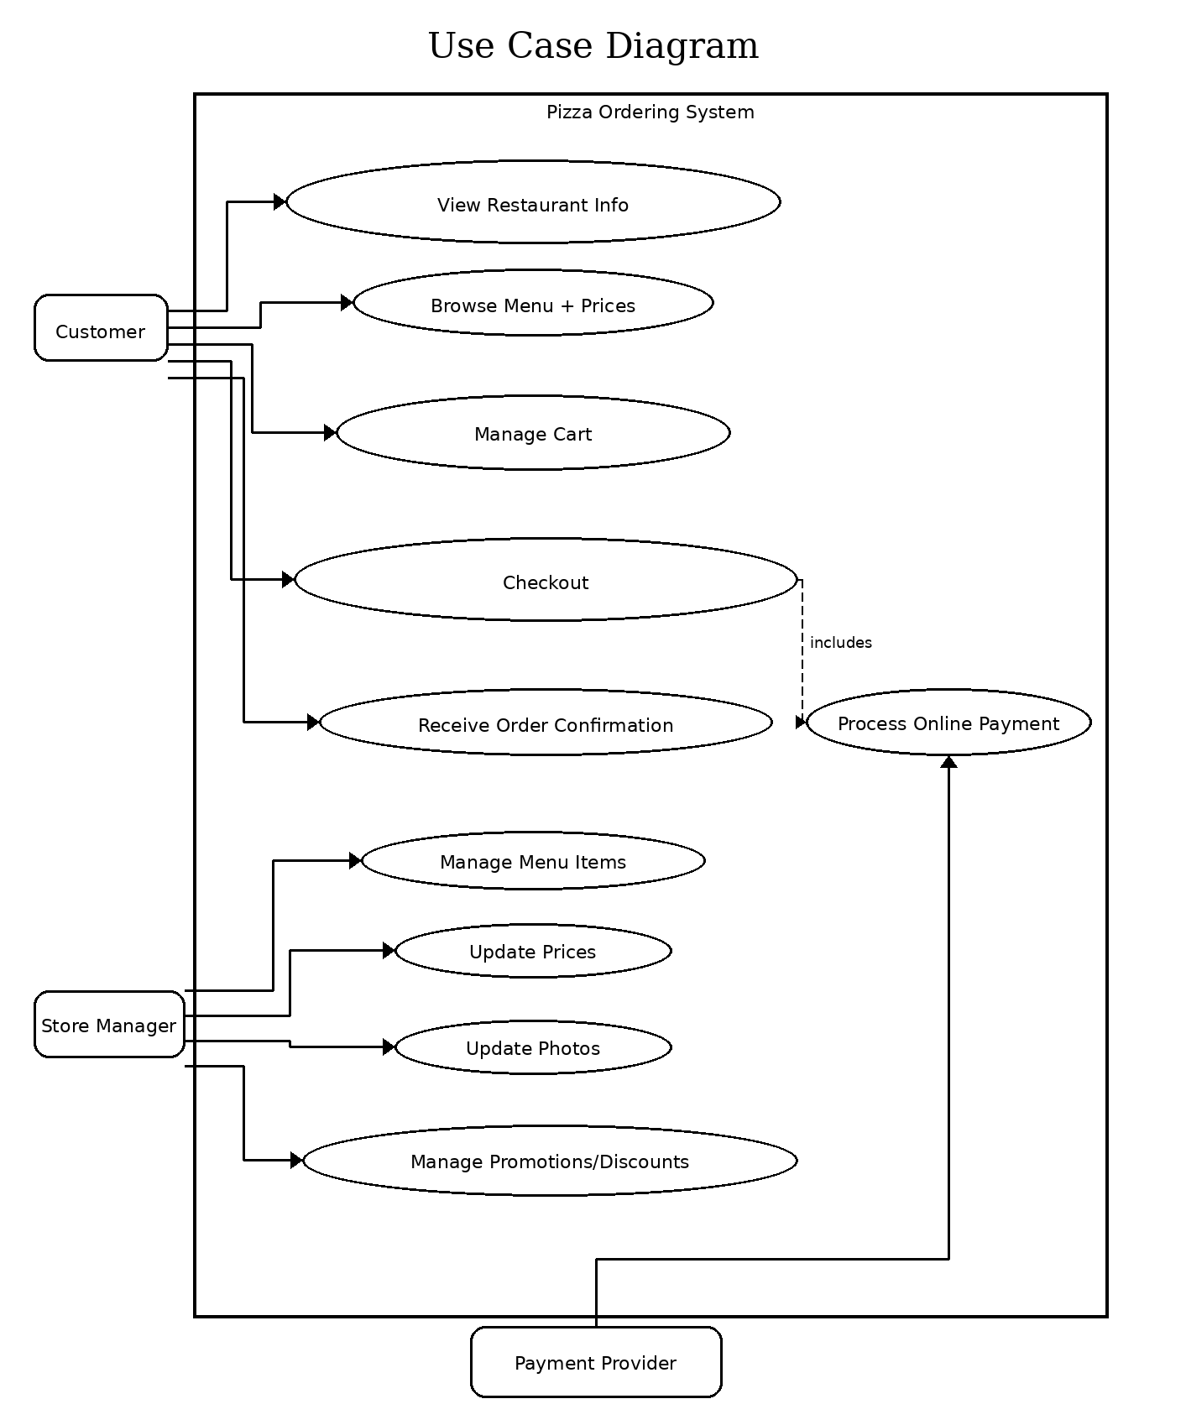
Figure 2. Use Case Diagram for Customer Ordering and Manager Administration

Domain Model and Core Components
At the domain level, the system is organized around MenuItem and Promotion (content), Cart (pricing and selection), Order (submitted purchase), and PaymentTransaction (external payment status). Service classes encapsulate business logic, while repositories abstract persistence.
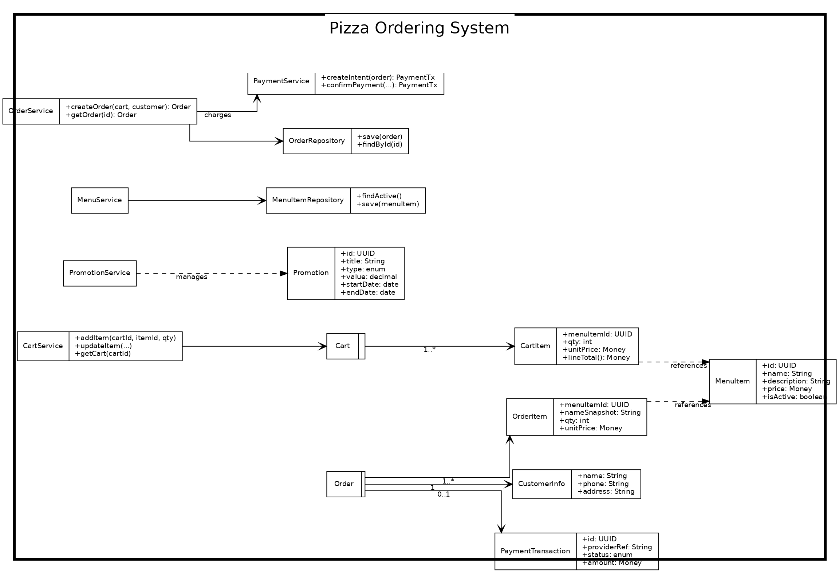
Figure 3. Core Domain Class Diagram for Menu, Cart, Orders, and Payments

Sprint 1 Detailed Design
Sprint 1 focuses on delivering a working MVP of browsing and cart management plus the foundations of the admin experience. The primary goal is to enable customers to browse menu/prices/promotions and build an order without confusion, while allowing the manager to maintain menu content without technical help.

Sprint 1 - Primary UI Pages
• Home / Restaurant Info: hours, photos, promotions summary.
• Menu: list menu items with prices; add-to-cart actions.
• Cart: view/update/remove items; display subtotal/discount/total.
• Admin (Manager): secured area to create/update/deactivate menu items and update prices/photos.

Sprint 1 - Key API Endpoints (logical)
• GET /api/menu (returns active menu items + prices).
• GET /api/promotions (returns active promotions/discounts).
• POST /api/cart/items, PATCH /api/cart/items/{id}, DELETE /api/cart/items/{id} (cart operations).
• GET /api/cart (returns itemized cart + calculated totals).
• Admin: POST/PUT/DELETE /api/admin/menu-items and POST/PUT /api/admin/photos (admin CRUD).

Sprint 1 - Data/Persistence Notes
• MenuItem table: name, description, price, active flag, image URL/reference.
• Promotion table: type/value/date range (read-only for customers; CRUD for admin).
• Cart can be session-based (client id) or stored temporarily server-side; totals calculated server-side for consistency.

Sprint 2 Detailed Design
Sprint 2 extends the MVP with secure online payment, order submission, and confirmation. It also expands admin management for promotions/discounts and hardens nonfunctional requirements (security controls, resiliency, and basic monitoring).

Sprint 2 - Checkout and Payment Flow
Checkout is implemented as a guided flow: collect minimal required customer data (name/phone/address), create a tokenized payment intent via the provider, support SCA/3DS challenges when prompted, then finalize the order and display a confirmation reference.
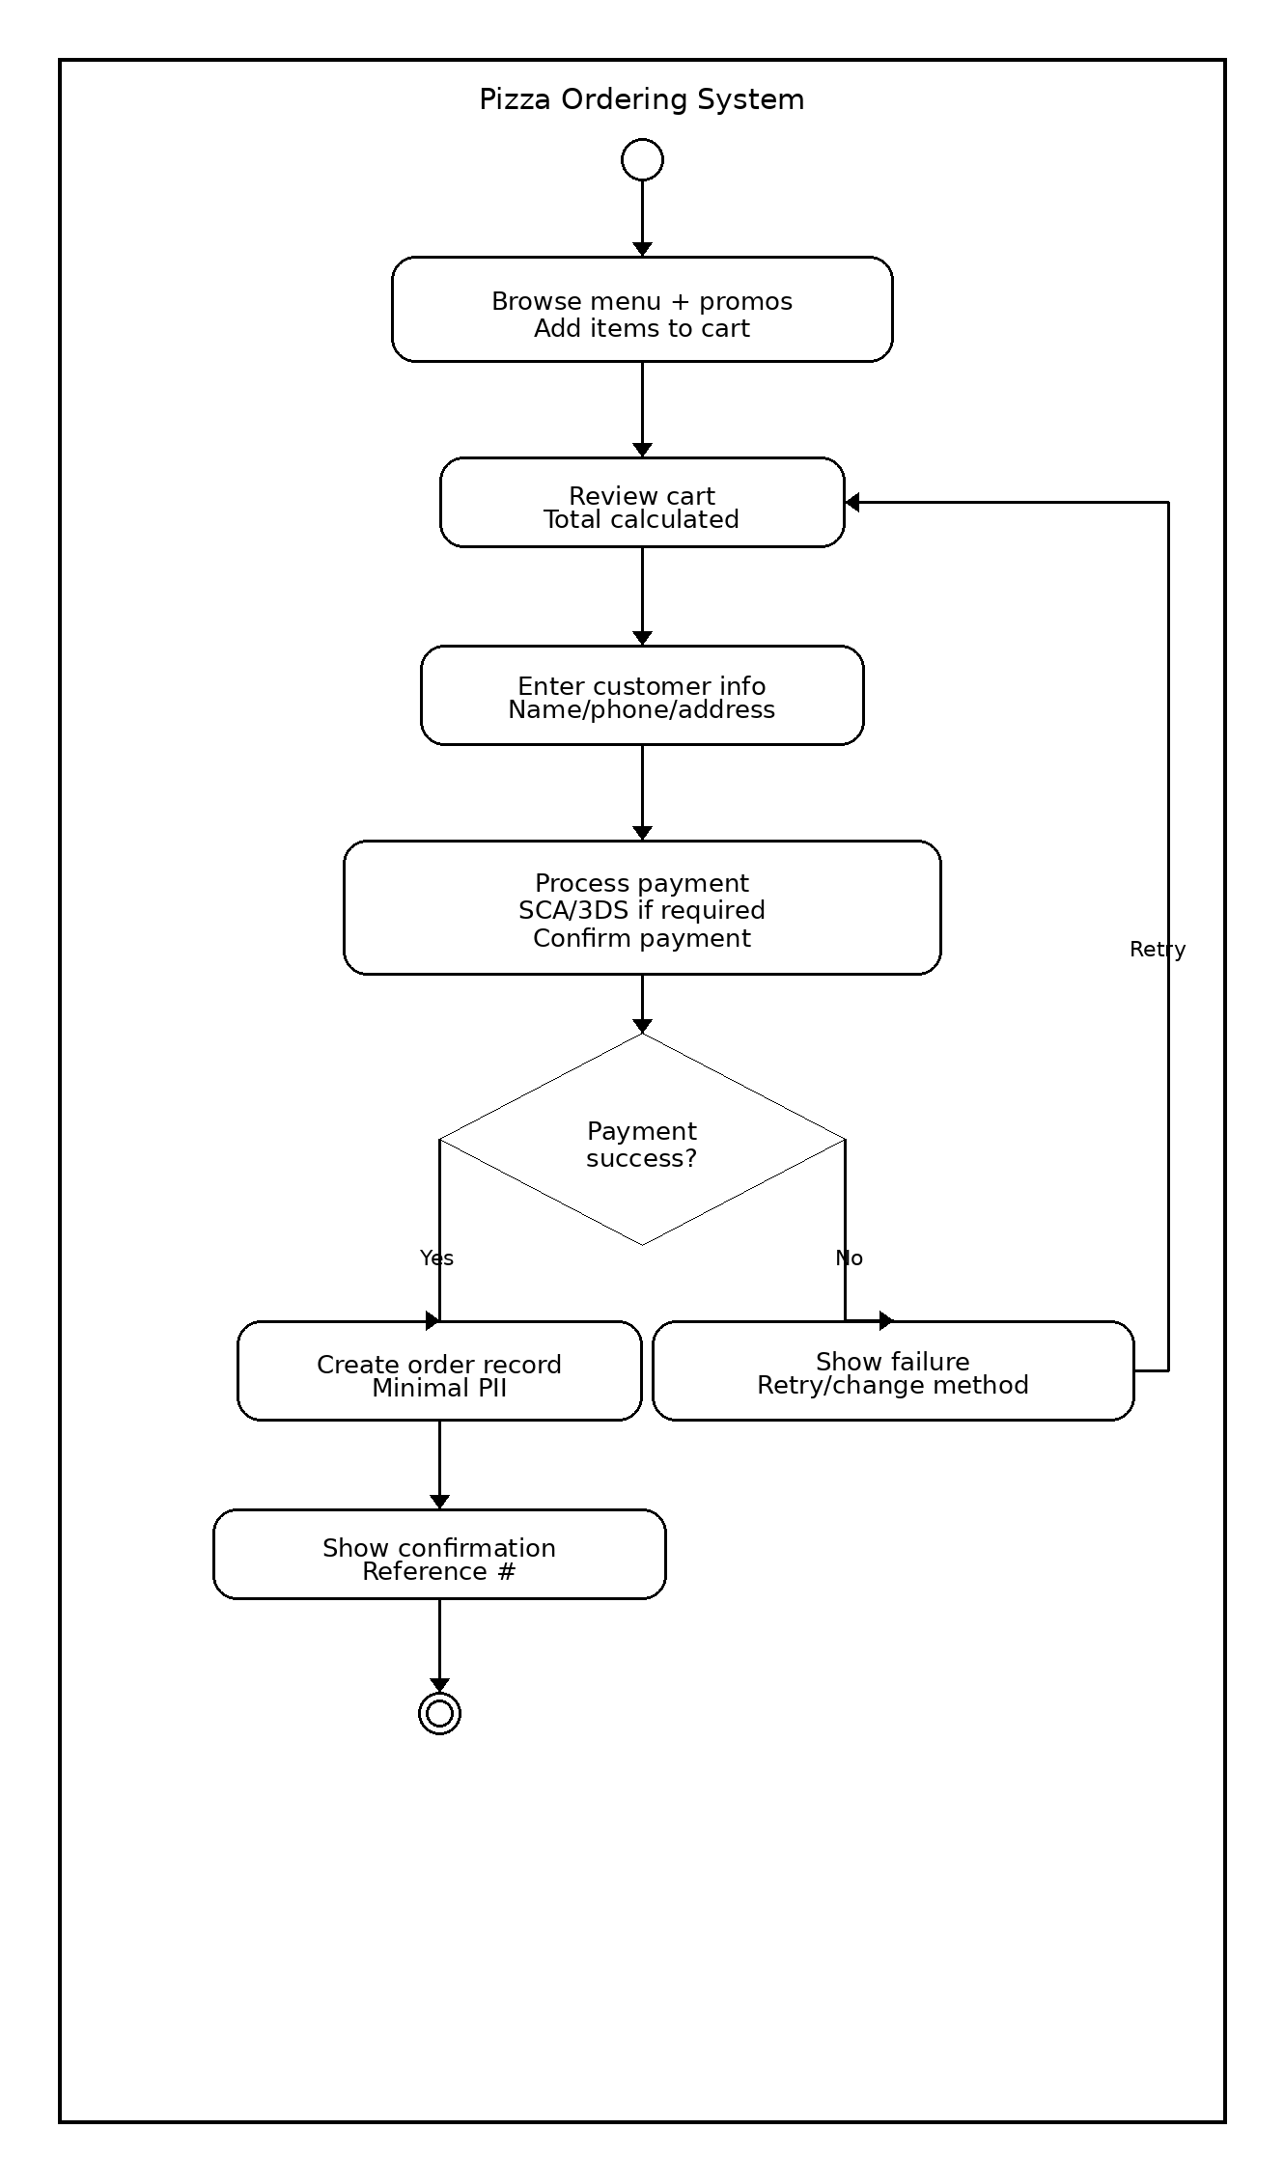
Figure 4. Activity Diagram for Checkout and Secure Payment Confirmation

Sprint 2 Payment Data-Flow Diagram and Trust Boundaries
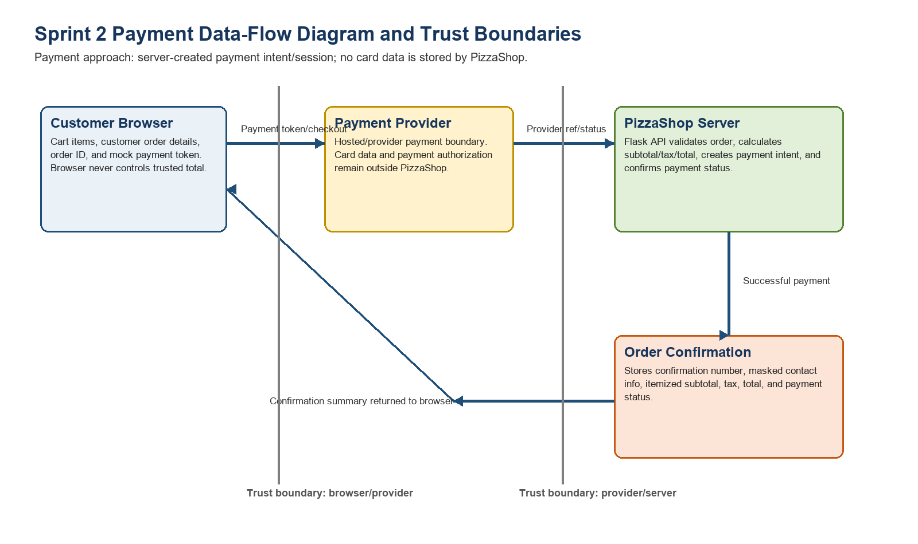
Figure 5. Payment Data-Flow Diagram and Trust Boundaries
The payment design uses a hosted/provider-style flow. The client sends the order ID and mock token, the server calculates the trusted subtotal, tax, and total, and the system stores only provider reference/status plus the order confirmation record. Card data is not stored by PizzaShop.

Sprint 2 - Key API Endpoints (logical)
• POST /api/orders (creates an order draft from the cart + customer info).
• POST /api/payments/intent (creates provider payment intent for the order total).
• POST /api/payments/confirm (confirms provider payment result; updates PaymentTransaction).
• GET /api/orders/{id} (returns order status + confirmation details).
• Admin: POST/PUT/DELETE /api/admin/promotions (manage discounts/promos).

Security and Nonfunctional Design
Security and nonfunctional controls are designed to align with the owner’s requirements for safe, dependable payments and minimal customer data.

Security Controls
• TLS everywhere (HTTPS) for all customer and admin traffic.
• Admin authentication and authorization (role-based access). Recommend MFA for manager/admin.
• Input validation + output encoding (OWASP Top 10 baseline) for forms and admin CRUD.
• CSRF protection for browser-based sessions; secure cookies; short session lifetimes for admin.
• Payment tokenization: do not store card numbers; store only provider reference + status.
• Audit logging for admin changes (menu/prices/photos/promotions) and payment state transitions.

Nonfunctional Requirements
• Scalability: stateless web/API tiers support horizontal scaling as order volume grows.
• Reliability: graceful handling of payment failures (retry path) and clear customer messaging.
• Performance: menu browsing and cart operations should remain responsive under expected daily load; caching can be used for menu/promotions.
• Privacy: collect/store only name, phone, address, and order details required for fulfillment; avoid accounts/saved profiles per exclusions.
• Maintainability: Separate UI and API; admin CRUD endpoints reduce reliance on developers for routine updates.

Design Coverage Statement
With the artifacts above, the design covers at least 50% of the project scope, including restaurant info display, menu/pricing, promotions, cart management, checkout/payment, order confirmation, and an admin panel for menu/prices/photos/promotions. Excluded features (accounts, loyalty programs, marketing automation) are intentionally omitted to remain aligned with scope.

Sprint 1 Retrospective Summary Report
Things That Went Well
- Team communication stayed pretty consistent throughout the sprint. Everyone stayed active and responded quickly when updates or questions came up.
- We were able to divide tasks based on each person’s strengths, which helped speed up development.
- The group worked well together during problem solving, especially when bugs or coding issues came up.
- We made solid progress on the main features planned for Sprint 1 and stayed close to our timeline.
- Collaboration tools like Google Collab and shared documents made it easier to track changes and work together remotely.
Things That Could Have Gone Better
- Testing could have been done earlier instead of waiting until later in the sprint.
- Communication was good overall, but there were moments where updates were delayed and slowed progress down.
- Time management became difficult at times because everyone was balancing work and personal responsibilities.
- Team members working on overlapping sections, which caused a little confusion and duplicate work
Things That Surprised Us
- The team adapted quickly when problems came up and found solutions fasster then expected
- Realization of how important regular check ins were for keeping everyone aligned.
- Small technical issues ended up creating bigger delays than expected
- Google Collab worked better for collaboration than some of us originally thought
Lessons Learned
- Clear communication at the start of the sprint helps avoid confusion later on
- Breaking large tasks into smaller steps makes work easier to manage and track.
- Assigning clear ownership of tasks helps prevent overlap and missed responsibilities.
- Flexibility is important because unexpected issues will always come up during development.
- Regular team meetings and progress updates help keep momentum going and improve accountability.

Sprint 2 Retrospective Summary Report
Things That Went Well
- We completed the main Sprint 2 checkout pieces by connecting order creation, payment intent creation, payment confirmation, and order confirmation lookup through API routes.
- The payment work followed the project’s security direction by keeping payment totals on the server and storing only the provider reference/status instead of card data.
- HTTPS-only deployment planning was strengthened with production settings, reverse proxy support, HTTP-to-HTTPS redirects, secure cookies, and browser security headers.
- The team added ZIP-based tax estimation and final total calculation, which made the checkout flow more realistic and aligned with the owner’s automatic final bill requirement.
- Documentation and supporting artifacts improved, including Sprint 2 completion notes, the payment data-flow/trust boundary diagram, and endpoint descriptions.
Things That Could Have Gone Better
- Sprint 2 involved several connected parts, so a clearer early integration checklist could have reduced risk between checkout, payment, tax calculation, and confirmation.
- More time should have been reserved for full environment testing because project dependencies, such as Flask and requirements installation, must be set up before the test runner can work.
- The API workflow became stronger than the UI workflow in some areas, so more time could have been spent walking through the complete customer experience in the browser.
- Some tasks touched the same checkout flow, which means earlier team review could have helped prevent late-stage integration issues.
- Documentation could have been updated in smaller pieces during the sprint instead of waiting until the end.
Things That Surprised Us
- Payment initiation was more involved than simply adding one endpoint because it required server-side totals, provider references, payment status changes, and the handoff to confirmation.
- The order-to-confirmation pipeline gave the project a more production-like structure than expected while still keeping the implementation simple enough for the class project.
- Small security settings, such as proxy headers, secure session cookies, and HSTS, mattered more once deployment planning was considered.
- ZIP-based tax estimation made the cart totals feel more realistic and showed why checkout calculations should be handled by the server.
- The event log made it easier to trace the flow from order placed, to payment intent created, to order confirmation created.
Lessons Learned
- Security and checkout should be designed as one connected workflow instead of being treated as separate tasks.
- The server should remain the source of truth for order totals, tax, and payment initiation because the client should not control the payment amount.
- API endpoints are easier to test and maintain when each step has a clear responsibility, such as creating the order, creating the payment intent, confirming payment, and returning confirmation details.
- Integration testing is especially important for user stories that cross multiple systems, such as checkout, payment, and confirmation.
- Keeping a simple event record helps with debugging, audit review, and future scalability if the project later moves from in-memory data to a database or message queue.

References

